|  |  |
| --- | --- |
| **Name** | Muhammad Arslan Raza |
| **Section** | A |
| **Roll no.** | 2020-EE-403 |

**Lab 10**

**Investigate the performance of Rankine cycle**

**Introduction:**

The **Rankine cycle** was named after him and describes the performance of **steam turbine systems**, though the theoretical principle also applies to reciprocating engines such as steam locomotives. In general,

* **Rankine cycle** is an idealized thermodynamic cycle of a constant pressure heat engine that converts part of heat into mechanical work. In this cycle the heat is supplied externally to a closed loop, which usually uses water (in a liquid and vapor phase) as the working fluid. In contrast to the Brayton cycle, the working fluid in the **Rankine cycle** undergo the **phase change** from a liquid to vapor phase and vice versa. This cycle produces 90% of the total electricity of world.
* The **Rankine cycle** or **Rankine** Vapor **Cycle** is the process widely used by power plants such as coal-fired power plants or nuclear reactors. In this mechanism, a fuel is used to produce heat within a boiler, converting water into steam which then expands through a turbine producing useful work.
* The **Rankine cycle** is a model used to predict the performance of **steam turbine** systems. It was also used to study the performance of reciprocating **steam** engines. The **Rankine cycle** is an idealized thermodynamic **cycle** of a heat engine that converts heat into mechanical work while undergoing phase change

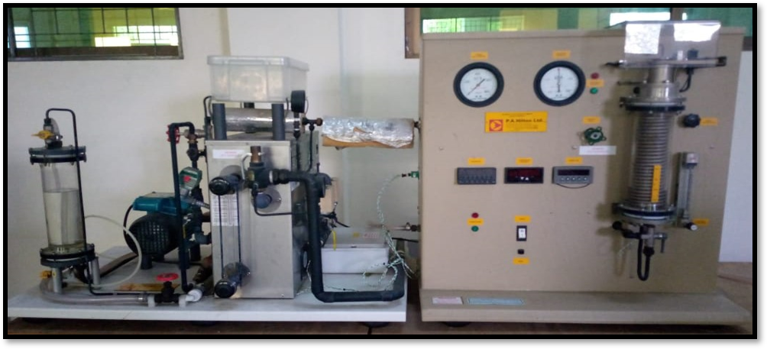

Figure 1:Model of Rankine cycle steam turbine

**Parts list and details:**

Following are the parts of Rankine cycle steam turbine:

* Boiler
* Turbine
* Condenser
* Pump
* Steam Pressure
* Condenser Pressure
* Tachometer
* Temperature Indicator
* Break Load Indicator
* Break Cooling water control
* Steam Solenoid Valve
* Steam Outlet After Boiler
* Throttle Valve
* Belt Break
* Tachometer Optical Sensor
* Impulse Turbine
* Break Cooling water outlet
* Three pipe steam
* Gauge
* Boiler Pressure
* Pressure Leave valve
* Boiler leave indicator

**Parts Explanation:**

**Boiler:**

The pump delivers liquid water to the boiler. The boiler heated by the solar heat converts water to superheated steam. This steam is used to run the turbine which powers the generator.

**Turbine:**

A turbine is a rotary mechanical device that extracts energy from a fluid flow and converts it into useful work. The work produced by a turbine can be used for generating electrical power when combined with a generator.

a) Nozzle b) Blade c) Rotor

**Nozzle:**

A **nozzle** is a device designed to control the direction or characteristics of a fluid flow (specially to increase velocity) as it exits (or enters) an enclosed chamber or pipe. A nozzle is often a pipe or tube of varying cross-sectional area, and it can be used to direct or modify the flow of a fluid (liquid or gas). Nozzles are frequently used to control the rate of flow, speed, direction, mass, shape, and/or the pressure of the stream that emerges from them. In a nozzle, the velocity of fluid increases at the expense of its pressure energy.

**Blade:**

A **turbine blade** is the individual component which makes up the turbine section of a gas turbine or steam turbine. The blades are responsible for extracting energy from the high temperature, high pressure gas produced by the combustor. The turbine blades are often the limiting component of gas turbines.

**Rotor:**

In a **turbine**, **rotor** blades are the means by which thermal/kinetic energy is transformed into rotating mechanical energy. **Rotor** blades are blades that are attached to a rotating shaft that runs through **turbines**, generators and sometimes air compressors.

**Brake:**

A counter steam **brake** is a **brake** on a **steam** locomotive that uses the **engine** (specifically the cylinders) to help **break** the locomotive.

**Pump:**

The **pumps** which are used in boiler feed applications increase the suction pressure of feedwater.

**Tachometer:**

A tachometer is an instrument measuring the rotation speed of a shaft or disk, as in a motor or other machine. The device usually displays the revolutions per minute (RPM) on a calibrated analogue dial.

**Temperature indicator:**

A simple digital temperature indicator designed to indicate temperature using a sensor.

**Steam solenoid valve:**

The name given as solenoid valve to the electromagnetic valve used to control fluids such as water, air, steam, gas etc

**Throttle valve:**

Throttling valve designed to regulate the supply of a fluid (as steam or gas and air) to an engine and operated by a handwheel, a lever.

**Impulse turbine:**

An impulse turbine is a turbine that is driven by high velocity jets of water or steam from a nozzle directed on to vanes or buckets attached to a wheel.

**Break load indicator:**

Steam flow to the turbine can be throttled by a hand valve and the boiler turbine inlet and condenser pressures are indicated on gauges. The impulse turbineis driven by a convergent divergent nozzle and turns a brake wheel with speed sensor and digital indicator allowing true shaft power to be determined.

**Boiler leave indicator:**

A water column is used on a steam boiler to reduce the turbulence and fluctuation of the water level so the gage glass can provide a steady, accurate water level reading. A gage glass is the most common form of level indicator found on steam boilers.

**Gauge:**

A gauge or gage, in science and engineering, is a device used to make measurements or in order to display certain dimensional information.

**Safety Valve:**

A transducer assists in regulating boiler pressure by cycling the burner on and off. A poppet valve, located on top of the boiler, serves as a safety valve.

**Basic Principle:**

* The **Rankine cycle** is an idealized thermodynamic **cycle** of a heat engine that converts heat into mechanical work while undergoing phase change.The heat is supplied externally to a closed loop, which usually uses water as the working fluid.
* The **Rankine cycle** is a model used to predict the performance of **steam turbine** systems. It was also used to study the performance of reciprocating **steam** engines. The **Rankine cycle** is an idealized thermodynamic **cycle** of a heat engine that converts heat into mechanical work while undergoing phase change as shown in figure.

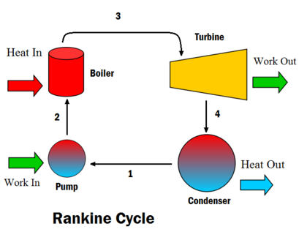**Diagram:**

**Explanation:**

In an ideal Rankine cycle, the system executing the cycle undergoes a series of four processes: two isentropic (reversible adiabatic) processes alternated with two isobaric processes:

**Process:**

* **Process 1–2:** [Isentropic compression in pump]

The working fluid is pumped from low to high pressure. As the fluid is a liquid at this stage, the pump requires little input energy.

**Process 2–3**: [Constant pressure heat addition in boiler]

* The high-pressure liquid enters a boiler, where it is heated at constant pressure by an external heat source to become a dry saturated vapor. The input energy required can be easily calculated graphically, using an [enthalpy–entropy chart](https://en.wikipedia.org/wiki/Enthalpy%E2%80%93entropy_chart) ([h–s chart](https://en.wikipedia.org/wiki/H%E2%80%93s_chart), or [Moliere diagram](https://en.wikipedia.org/wiki/Mollier_diagram)), or numerically, using [steam tables](https://en.wikipedia.org/wiki/Steam_table).
* Input is that material which is most common in the region or country.

**Process 3–4**: [Isentropic expansion in turbine]

* The dry saturated vapor expands through a [turbine](https://en.wikipedia.org/wiki/Turbine), generating power. This decreases the temperature and pressure of the vapor, and some condensation may occur. The output in this process can be easily calculated using the chart or tables noted above.

**Process 4–1**: [Isentropic expansion in turbine]

* The wet vapor then enters a [condenser](https://en.wikipedia.org/wiki/Surface_condenser), where it is condensed at a constant pressure to become a [saturated liquid](https://en.wikipedia.org/wiki/Boiling_point) by cool water.

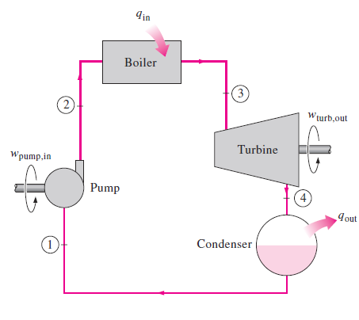

Figure 2: Cyclic diagram of Rankine Cycle

**PV and Ts diagram of Rankine cycle:**

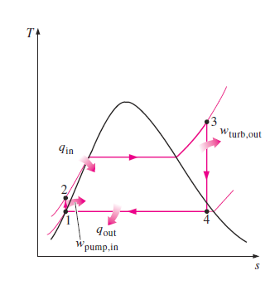

Figure 3: Ts diagram of Rankine cycle

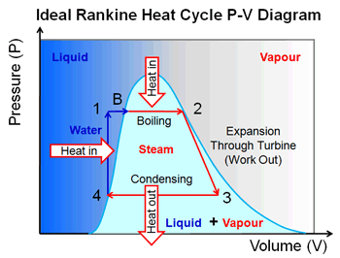

Figure 4: PV diagram of Rankine cycle

**Temperatures:**

T1= turbine inlet

T2 = Condenser outlet

T3 = Cold water that in the condenser (inlet)

T4 = Cold water that in the condenser (outlet)

T5 = Condensed water temperature that is in the Hollow condenser

T6 = Pump inlet (Tube makeup tank)

T7 = Boiler outlet (steam temperature)

T8 = After valve temperature

**Application:**

Steam turbines are a part of various industries, from medium to large scale, and include dozens of institutional applications.

* Chemical Industry: Providing heat and electricity to drive different processes in the chemical and pharmaceutical industries, steam turbines are integrated in the process of producing power.
* Waste Plants: Steam turbines help generate the power needed to harness energy from wastes.
* Oil & Gas: Used as a pump drive or a compressor, steam turbines support dozens of operations in the oil and gas industry.
* Sugar Mills: Offering high levels of efficiency and sustainable operations, steam turbines are used to produce green carbon-dioxide energy from bagasse.

Some of the most popular applications of a steam turbine in different industries include the following:

1.      Combined Heat and Power

2.      Driving Mechanical Equipment

3.      District Heating & Cooling Systems

4.      Combined Cycle Power Plants